A-life Alphabet Fitness Code

A = Army Crawls
B = Basketball side steps
C = Cycling
D = Dancing
E = Elephant lunges
F = Fireworks
G = Gliders
H = Hops
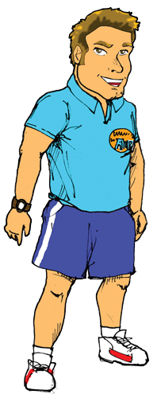
I = Ice climbers
J = Jumps
K = Knees down (stand up)
L = Log chop
M = Marching
N = Netball moves
O = Octopus wiggles
P = Push ups
Q = Quick feet
R = Rodeo
S = Star jumps
T = Toe touches
U = Ultra slow mo
V = V-sits
W = Watch
X = X legs
Y = Yawn
Z = Zig zag

And remember..
Space
# (to start and finish)

YOUR CHALLENGE:
- Practise the alphabet moves a few times. Why not try it backwards too?
- Try spelling your name, street name, pet’s name…
- Send a video message to your teachers using the alphabet code!
- If your parents/carers add any videos on social media please copy us in and use #alphabetchallenge #alife onto the handles below.

Visit www.a-life.co.uk for more information.
We hope you and the children enjoy completing the challenge. Please keep in touch on Social Media!
Like us @Alife.healthy.schools follow us @A_lifeltd follow us @Alifeltd

